Modelling the architecture of hazelnut (Corylus avellana) over two successive years.

F. Grisafi1, S. Tombesi1, D. Farinelli2, F. Boudon3,4, J.B. Durand5, E. Costes3

1Department of Sustainable Crop Production, Università Cattolica del Sacro Cuore, Via Emilia Parmense 84, 29122 Piacenza, Italy, 2Dipartimento Di Scienze Agrarie, Alimentari Ed Ambientali, Università degli studi di Perugia, Via Borgo 20 giugno 74 , 06123 Perugia, Italy, 3UMR AGAP Institut, Univ Montpellier, CIRAD, INRAE, Institut Agro, F-34398 Montpellier, France, 4 CIRAD, UMR AGAP Institut, F-34398 Montpellier, France, 5Univ. Grenoble Alpes, Inria, CNRS, Grenoble INP, LJK, Inria Grenoble Rhône-Alpes, France

**Abstract**

**Keywords**

**Introduction**

In recent decades, complex models have been developed to describe the growth and development of trees and crops (DeJong, 2019; Louarn and Song, 2020). Those models, called Functional-Structural Plant Models (FSPMs) merge two different sub-models: one simulating the architectural part of the tree or crop and the other simulating its functions, mainly in interaction with environmental conditions (Room et al., 1996; Sievänen et al., 2014). The construction of an FSPM, usually, starts from the simulation of the plant architecture to which, physiological models are added (for reviews see (Grisafi et al., 2021; Vos et al., 2010)). The architectural part is crucial to virtually represent the spatial and topological distribution of the different organs. This permits to link their position with the functional processes that occur within each of them (Sievänen et al., 2000). One of the most interesting uses of FSPMs is to address research and practical questions. In fact, the use of such models permits to investigate different physiological processes (i.e. the effect of water stress or fruit thinning on carbon partitioning (Allen et al., 2005)) or managerial techniques (i.e. effects of different rootstock on tree’s yield (Da Silva et al., 2015)). This permits to benefit of the possibility of making *in silico* experiments to choose if it is worthwhile investing in dedicated experiments in field (DeJong, 2019; Vos et al., 2007).

Plant structure is the result of two fundamental processes: **apical growth**, from the apical meristem and **branching processes** from axillary meristems (Gifford and Foster, 1987). To describe plant structure, the different elements must be specified (e.g. shoot, fruits, leaves), possibly with different characteristics: their composition (e.g. the number of elements at a finer scale), their geometry (e.g. length), their position concerning other organs (i.e. topology), and the timing of growth (e.g. sylleptic or proleptic shoots) (Costes et al., 2006; Godin and Caraglio, 1998). In perennial plants growing in temperate climates, those processes are usually investigated, over different years, during winter because the plant structure is more accessible without leaves. To investigate branching, it has been proposed to focus on 1-year-old shoots and record the type of bud at each node (Caraglio and Barthélémy, 1997; Costes and Guédon, 2002). The node scale is usually chosen because of the strong effect of its position along the shoot on the type of bud and the development of new shoots (Caraglio and Barthélémy, 1997).

Moreover, the position of the longest lateral shoots along a parent shoot allows distinguishing acrotonic (i.e. apple (Lauri, 2007)) or basitonic (i.e. olive (Bongi and Palliotti, 1994)) branching (Caraglio and Barthélémy, 1997; Champagnat, 1954). Those qualitative descriptions can be complemented by **exploratory quantitative analyses** followed by more complex statistics that permit gaining a deeper understanding of the topological relationship between the different organs that compose the plant (Durand et al., 2005; Guédon et al., 2001). The most widely used analysis have been **Markovian models** (Taylor and Karlin, 1998)that permit the identification of homogeneous branching zones within the shoot and the estimation of their characteristics, e.g zone length (Costes et al., 2008; DeJong et al., 2012; Durand et al., 2005). Recent studies have proposed **generalized-linear models** (GLMs) to analyse the relationship between a variable (e.g.length of lateral shoots) with one or more predictors (i.e. length of the bearer shoot, rank node) (Boudon et al., 2020). Those models are easier to estimate than Markovian ones. Thus, they can be used per se or as a complementary analysis to be incorporated into more complex ones (Boudon et al., 2020).

Despite hazelnut is an emerging fruit crop and its cultivation is increasing worldwide (FAOSTAT, 2020), few attempts have been made for modelling it so far. A process-based model that simulates the yield was recently developed (Bregaglio et al., 2020), but, nowadays, the structural model is still missing. Several challenges need to be addressed when modelling hazelnut architecture. Hazelnut is a bushy fruit tree with basitonic branching mode at tree level and acrotonic gradient ad shoot level (Figure 1). Every year, very long shoots, called suckers are produced, since the tree’s age is 4 years old, from latent buds located at the bottom of the main shoots. Along one-year-old shoots, the successive nodes can bear one or more axillary buds whose fate can be latent (B), male flower (catkin= C), mixed bud (M), or vegetative bud (V) (Germain and Sarraquigne, 2004). Vegetative buds will give birth, the following year, to a new vegetative shoot. Mixed buds will behave as vegetative buds except for the presence of the female inflorescence at their apex (Germain and Sarraquigne, 2004). Several studies and books describe the biology and physiology of reproductive organs of hazelnut (i.e. M and C) (Germain, 1994; Mehlenbacher, 1991). However, they paid no attention to the dynamic of axillary shoot emergence and to the presence of sylleptic shoots (i.e. axillary meristem developing the same year as their parent shoot; see Caraglio and Barthélémy, 1997).



In this study, we performed a detailed characterization of hazelnut architectural development, including observation of shoot emergence positions and dynamics. We thus distinguished sylleptic and proleptic shoots. For this, specific experiments and observations were performed to understand how those plant elements are connected to each other and how they contribute to plant development. This work thus aimed to perform by successive steps the observation of hazelnut architectural development and the quantification of bud fates depending on the developmental time and location along their parent shoot, as elementary knowledge required before the implementation of a model of hazelnut (*Corylus avellana)* architecture.

**Material and methods**

DATASET

The experiment was carried out in Deruta, Perugia (Italy) in 2020 and 2021. The experimental orchard contained 140 hazelnut trees (Corylus avellana, cv. Tonda di Giffoni), planted in 2014 at 4x4m distances. Standard horticultural care was applied. In January 2020, 104 1-year-old shoots of own-rooted hazelnut trees were selected according to four length categories:: short (Sh) when shorter than 5 cm, medium (Me) when between 5 and 20cm, long (Lo) when between 20 and 40cm, and very long (VLo) when longer than 40cm. On this selection of shoots, biometrical measurements (i.e. diameter, length, and number of nodes) were performed during winter. From the base to the shoot tip, at each node, the number and fates of buds were recorded. Four types of fates are possible in C. avellana: latent bud (i.e. when no bud was present, B), vegetative bud (V), mixed bud (M), and male flower (catkins = C). Throughout the measurements, it was noticed that catkins are present only in the apical position of short shoots, which have 5-6 axillary buds, and had grown in the same year as the parent shoot (Figure 2). We thus, detected from those observations, the presence of sylleptic shoots. In January 2021, the same biometrical measurements and node-per-node records were performed on lateral 1-year-old-shoots born from vegetative and mixed buds of shoots previously selected in 2020 (Figure 3). In the following, 1-year-old shoots of 2020 will be considered as **parent shoots** or **bearers**, while the shoots born from their buds in 2021 will be named **children shoots.** The analysis of axillary bud production, either in the same year **(sylleptic lateral shoots)** or in the next year **(proleptic lateral shoot)** will correspond to the **branching pattern** analysis**.**

STATISTICAL ANALYSES

All statistical analyses were performed at UMR AGAP Institute, Montpellier (France) in 2022 using RStudio (Guédon et al., 2001; R Core Team, 2022). First, exploratory analysis of the data was done. It gave a first idea of the branching patterns in hazelnut. After that, each box of the model, representing an architectural question, was answered using more complex statistics (Figure 4). Generalized-linear models (GLMs) were used to evaluate the relationship between dependent and independent variables in MOD1, MOD2, MOD5, and MOD6 (Figure 4). A multinomial regression model (MLRM) was used to evaluate the proportion of buds in proleptic shoots according to different factors (MOD4, Figure 4). GLMs were performed using “stats” package (R Core Team and contributors worldwide, 2022), while “nnet” package (Ripley and Venables, 2022) was used to run MLRM. Each GLM was first run using all the possible predictors. Then permutation models and AIC comparisons were done to remove, each time, the less significant predictor (Olivier et al., 2021). “fitdistrplus” package (Delignette-Muller and Dutang, 2015) was used to find the best distribution curve to plot the length of new shoots born from buds in sylleptic shoots (MOD3, Figure 4). “shapr” package (Aas et al., 2019; Sellereite et al., 2021) was used to explain the best predictor in the GLM which described the proportion of new shoots in proleptic shoots (MOD5, Figure 4).

The outputs of all final models will, then, be coded in L-Py (Boudon et al., 2012) for a visual representation of the plant development.

STRUCTURE OF THE ANALYSIS

A flux diagram of the architectural model was drawn (Figure 4). Different scales are possible within the model: shoot scale (circled boxes), node scale (square boxes), and bud scale (rhomboid boxes) (Figure 4). The model starts with the assumption that the first shoot is lateral and proleptic. The number of nodes of this shoot is computed. Then, for each node, the model will explore if that node has a sylleptic shoot or not. If yes, it will follow the yellow side of the diagram, if not, it will continue with the investigation (Figure 4). The number of buds at that node will be computed as well as the bud fate. If the node is blind or the bud will not sprout, the model will consider it as a latent bud. In contrast, if the mixed or vegetative bud sprouts, it will compute the length of the new lateral shoot, and the diagram will repeat itself from the beginning.

**Result and discussion**

In the past years, few attempts have been made to investigate the activity of meristem in hazelnut trees. In fact, catkins have always been located in the axillary position of a proleptic shoot (Germain and Sarraquigne, 2004) and they have been never addressed as sylleptic shoots themselves. Furthermore, the branching position was described as basitonic (Botta and Valentini, 2018), while a distinction should be made between the branching mode at a tree scale and at the shoot scale, as shown by our analysis (Figure 1 and Figure 10) and suggested by Germain and Sarraquigne (2004). In addition, few studies were carried on to define if hazelnut branching mode was monopodial (i.e. when the apical meristem remains dominant) or sympodial (i.e. when the apical meristem dies) (for a review see Costes et al. (2006) ). A study carried out in Slovenia noticed the sympodial branching on both cultivars studied (A. Solar and F. Štampar, 2005). We can confirm the same branching mode in Tonda di Giffoni where the death of the apical bud was observable during the growing season (Figure 11). Given this, we will present the results of the analysis of axillary bud production in a paragraph named “BRANCHING PATTERN”. It is divided into two sub-paragraphs: “PROLEPTIC SHOOT”, for the analysis of the products that happen in the next year; and “SYLLEPTIC SHOOT” for the analysis of the products that happen in the same year.

BRANCHING PATTERN

The model computes, per each node, the probability of having a sylleptic shoot (Figure 4). Sylleptic shoots are more frequent in the middle part of the shoot. This is in accordance with literature where in cv. “Tonda Gentile delle Langhe” male flowers were found mainly in the median part of the shoots (Tombesi and Farinelli, 2014). For each node in the parent shoot, the distance from the median node was computed and related to the probability of having a sylleptic shoot at that node (**MOD1**: Figure 5). Indeed, the proportion of sylleptic shoots was higher when the distance is 0 (i.e. the median rank node) and lower when the distance increased (i.e. the basal or final part of the shoot).

SYLLEPTIC SHOOTS

The number of vegetative plus mixed buds in sylleptic shoots was computed using the length of the bearer shoot and the distance from the median node as predictors. The number of buds increases with the length of the shoot and with the proximity of the median zone. Once the number of total buds (i.e. mixed plus vegetative buds) in the sylleptic shoot is computed, the model counts how many of each type (i.e. mixed or vegetative buds) are present in that sylleptic. For each type, the probability of bursting is computed. A binomial GLM with interaction was chosen because the probability of bursting, in sylleptic shoots, was influenced either by the fate of the bud itself (i.e. mixed or vegetative) or by the presence, in the same sylleptic shoot, of other mixed or vegetative buds (**MOD2:** Figure 6, Table 2). In fact, for vegetative buds, the probability of sprouting decreases with the increase of other vegetative buds while the presence of other mixed buds showed no significance (**MOD2:** Table 2). The same but opposite behaviour was observable for mixed buds whose probability of bursting decreased with the presence of other mixed buds and the presence of other vegetative buds was not significant (**MOD2:** Figure 6, Table 2).

However, the length of new shoots was not related to any of the tested parameters. Thus the distribution of length, for new shoots born from both M or V buds, was plotted (**MOD3:** Figure 7). The distribution length could be approximated to a gamma distribution with α=2.37 and β=1.20.

PROLEPTIC SHOOTS

The majority of the nodes did not bear a sylleptic shoot. Instead, the node bears one or more axillary buds. The number of buds per rank node is computed by the model (Figure 4). Then, the proportion of each type of bud (i.e. B, M, V) is given through a multinomial function (**MOD4:** Figure 8). The proportion of blind nodes (B) is higher in the basal part of the proleptic shoot (i.e. lower rank nodes) and then it decreases in the distal part (i.e. higher rank nodes). Mixed buds (M), on the contrary, are minimum in the basal and distal part of the shoot. This seems to be in contrast with literature where, in cv. “Tonda Gentile delle Langhe”, female flowers were found mainly in the distal part of the shoot (Tombesi and Farinelli, 2014). Vegetative buds have their maximum value in the middle and distal part of the shoot (**MOD4:** Figure 8). If the fate is blind (B) the model will skip to the next node and it will be analysed in the same way as the previous node (Figure 4). If the fate is either V or M, for each bud (if there are many), the probability of sprouting will be computed (**MOD5:** Figure 9, Table 3). The proportion of new shoots from M or V buds in proleptic shoots decreased when there were other buds (either V or M) in the same node. On the contrary, the probability of sprouting increases when the bud was in the distal part of the shoot (**MOD5:** Figure 9, Table 3). The final computation regards the length in cm of the new shoot (Figure 4). The new shoot length varies from 1 to 8cm according to the fate of the bud from which they were born, the length of the parent, and the distance from the median rank node (**MOD6:** Figure 10, Table 1Table 4). New shoots coming from V buds are usually longer than those from M buds. This is because the latter are pre-formed shoots with the female flower in terminal position (Germain and Sarraquigne, 2004). New shoots are longer, both those sprouting from M buds or V buds, when they are is in the distal part of the bearer (**MOD6:** Figure 10, Table 3). Hazelnut has always been described as a bushy tree with basitonic behaviour (Botta and Valentini, 2018). However, the analysis, shows how longer new shoots are present in the distal part of the parent shoot. This could suggest that is true that hazelnut has a basitonic behaviour at the tree level, giving the tree the bushy shape, and acrotonic behaviour at the shoot level with longer shoots in the distal position (Figure 1 and **MOD6:** Figure 10). This is in accordance with what is described in literature (Germain and Sarraquigne, 2004; Tombesi, 1985). At the very end, the model updates the order of the shoot from n (i.e. the bearer) to n+1 (i.e. the new shoot) and all the computations start again to simulate a new year of development (Figure 4).

**Conclusion**

A first and coarse structural model of hazelnut was built. The development of hazelnut buds was monitored over two successive years. During the time of the study, the presence of sylleptic shoots on hazelnut was detected. Thus all the buds on sylleptic shoots, and the new shoots sprout from them, were treated separately (Figure 4). Further investigations on sylleptic shoots development are needed to find more precise functions to describe their growth. The logical diagram of the model and the equations explained before in the paper, will be used to draw the visual representation of hazelnut development, through L-py program (Boudon et al., 2012) as it was done in other fruit tree crop models (Boudon et al., 2020; Costes et al., 2008). This architectural model could be implemented by adding, after accurate field experiments experiment, the architectural behaviour of the tree during the juvenile phase (Borchert, 1976). Further studies will be required to create a functional model that describes carbon partitioning within the tree. Finally, the architectural model could be merged with the functional one to have a FSPM of hazelnut.

**Acknowledgements**

**Citations and literature cited**

A. Solar, and F. Štampar (2005). The architectural analysis of a fruiting branch in two hazelnut cultivars. Acta Hortic. *686*, 179–186. .

Allen, M.T., Prusinkiewicz, P., and DeJong, T.M. (2005). Using L-systems for modeling source-sink interactions, architecture and physiology of growing trees: The L-PEACH model. New Phytol. *166*, 869–880. https://doi.org/10.1111/j.1469-8137.2005.01348.x.

Bongi, G., and Palliotti, A. (1994). Olive. In Handbook of Environmental Physiology of Fruit Crops:Temperate Crops, A. Palliotti, ed. (Cleveland: CRC Press. Inc.), pp. 165–187.

Borchert, R. (1976). The concept of juvenility in woody plants. Acta Hortic. *5*, 21–36. https://doi.org/10.17660/actahortic.1976.56.1.

Botta, R., and Valentini, N. (2018). Il nocciolo. Progettazione e coltivazione del corileto.

Boudon, F., Pradal, C., Cokelaer, T., Prusinkiewicz, P., and Godin, C. (2012). L-Py: An L-system simulation framework for modeling plant architecture development based on a dynamic language. Front. Plant Sci. *3*, 76. https://doi.org/10.3389/fpls.2012.00076.

Boudon, F., Persello, S., Jestin, A., Briand, A.S., Grechi, I., Fernique, P., Guédon, Y., Léchaudel, M., Lauri, P.É., and Normand, F. (2020). V-Mango: A functional-structural model of mango tree growth, development and fruit production. Ann. Bot. *126*, 745–763. https://doi.org/10.1093/aob/mcaa089.

Bregaglio, S., Giustarini, L., Suarez, E., Mongiano, G., and De Gregorio, T. (2020). Analysing the behaviour of a hazelnut simulation model across growing environments via sensitivity analysis and automatic calibration. Agric. Syst. *181*, 102794. https://doi.org/10.1016/j.agsy.2020.102794.

Caraglio, Y., and Barthélémy, D. (1997). Revue critique des termes relatifs à la croissance et à la ramification des tiges des végétaux vasculaires. In Modélisation et Simulation de l’Architecture Des Végétaux, J. Bouchon, P. de Reffye, and D. Barthélémy, eds. (Science Update INRA), pp. 11–88.

Champagnat, P. (1954). Les corrélation sur la rameau d’un an des végétaux ligneux. Phyton (B. Aires). *4*, 1–101. .

Costes, E., and Guédon, Y. (2002). Modelling branching patterns on 1-year-old trunks of six apple cultivars. Ann. Bot. *89*, 513–524. https://doi.org/10.1093/aob/mcf078.

Costes, E., Lauri, P.E., and Regnard, J.L. (2006). Analyzing fruit tree architecture: implications for tree management and fruit production. In Horticultural Reviews, J. Janick, ed. (Montpellier, France.: John Wiley & Sons, Inc.), p.

Costes, E., Smith, C., Renton, M., Guédon, Y., Prusinkiewicz, P., and Godin, C. (2008). MAppleT: Simulation of apple tree development using mixed stochastic and biomechanical models. Funct. Plant Biol. *35*, 936–950. https://doi.org/10.1071/FP08081.

DeJong, T.M. (2019). Opportunities and challenges in fruit tree and orchard modelling. Eur. J. Hortic. Sci. *84*, 117–123. https://doi.org/10.17660/eJHS.2019/84.3.1.

DeJong, T.M., Negron, C., Favreau, R., Day, K.R., Lopez, G., Costes, E., and Guédon, Y. (2012). Using concepts of shoot growth and architecture to understand and predict responses of peach trees to pruning. Acta Hortic. *962*, 225–232. https://doi.org/10.17660/ActaHortic.2012.962.32.

Durand, J.B., Guédon, Y., Caraglio, Y., and Costes, E. (2005). Analysis of the plant architecture via tree‐structured statistical models: the hidden Markov tree models. New Phytol. *166*, 813–825. https://doi.org/10.1111/j.1469-8137.2005.01405.x.

El-Habil, and M., A. (2012). An application on multinomial logistic regression model. Pakistan J. Stat. Oper. Res. *8*, 271–291. https://doi.org/10.18187/pjsor.v8i2.234.

FAOSTAT (2020). FAOSTAT.

Germain, E. (1994). The reproduction of hazelnut(Corylus avellana L.): a Review. Acta Hortic. 195–209. .

Germain, E., and Sarraquigne, J.-P. (2004). Le noisetier (Paris).

Gifford, E.M., and Foster, C.E. (1987). Morphology and Evolution of Vascular Plants. (New York, USA: W.H Freeman and Company).

Godin, C., and Caraglio, Y. (1998). A multiscale model of plant topological structures. J. Theor. Biol. *191*, 1–46. https://doi.org/10.1006/jtbi.1997.0561.

Grisafi, F., DeJong, T.M., and Tombesi, S. (2021). Fruit tree crop models: an update. Three Phisiology.

Guédon, Y., Barthélémy, D., Caraglio, Y., and Costes, E. (2001). Pattern analysis in branching and axillary flowering sequences. J. Theor. Biol. *212*, 481–520. https://doi.org/10.1006/jtbi.2001.2392.

Lauri, P.E. (2007). Differentiation and growth traits associated with acrotony in the apple tree (Malus Xdomestica, Rosaceae). Am. J. Bot. *94*, 1273–1281. https://doi.org/10.3732/ajb.94.8.1273.

Louarn, G., and Song, Y. (2020). Two decades of functional-structural plant modelling: Now addressing fundamental questions in systems biology and predictive ecology. Ann. Bot. *126*, 501–509. https://doi.org/10.1093/aob/mcaa143.

Mehlenbacher, S.A. (1991). Hazelnuts (Corylus). Acta Hort. *290*, 791–836. .

Nelder, J.., and Wedderburn, R.W.M. (1972). Generalized linear models. J. R. Stat. Soc. Ser. A *135*, 370–384. .

Olivier, B., Durand, J.-B., and Guérin-Dugué, A. (2021). Hidden Semi-Markov Models to Segment Reading Phases from Eye Movements. Submitted.

R Core Team (2022). R: A language and environment for statistical computing.

R Core Team and contributors worldwide (2022). The R Stats Package.

Ripley, B., and Venables, W. (2022). nnet.

Room, P., Hanan, J., and Prusinkiewicz, P. (1996). Virtual plants: new perspectives for ecologists, pathologists and agricultural scientists. Trends Plant Sci. *1*, 33–38. .

Sievänen, R., Nikinmaa, E., Nygren, P., Ozier-Lafontaine, H., Perttunen, J., and Hakula, H. (2000). Components of functional-structural tree models. Ann. For. Sci. *57*, 399–412. https://doi.org/10.1051/forest:2000131.

Sievänen, R., Godin, C., De Jong, T.M., and Nikinmaa, E. (2014). Functional-structural plant models: A growing paradigm for plant studies. Ann. Bot. *114*, 599–603. https://doi.org/10.1093/aob/mcu175.

Da Silva, D., Favreau, R.O., Tombesi, S., and De Jong, T.M. (2015). Modeling size-controlling rootstock effects on peach tree growth and development using L-PEACH-h. Acta Hortic. *1068*, 227–234. https://doi.org/10.17660/actahortic.2015.1068.28.

Taylor, H.M., and Karlin, S. (1998). An introduction to stochastic modeling. (Orlando, FL: Academic Press.).

Tombesi, A. (1985). Il nocciolo: manuale pratico.

Tombesi, S., and Farinelli, D. (2014). Relationships between flower density and shoot length in hazelnut (Corylus avellana L.). In Acta Horticulturae, (Thompson), pp. 137–142.

Vos, J., Marcelis, L.F.M., and Evers, J.B. (2007). Functional-structural plant modelling in crop production: adding a dimension. In Functional-Structural Plant Modelling in Crop Production, J. Vos, L.F.M. Marcelis, P.H.B. DeVisser, P.C. Struik, and J.B. Evers, eds. (Wagenigen, The Netherlands: Springer), pp. 1–12.

Vos, J., Evers, J.B., Buck-Sorlin, G.H., Andrieu, B., Chelle, M., and De Visser, P.H.B.B. (2010). Functional-structural plant modelling: A new versatile tool in crop science. J. Exp. Bot. *61*, 2101–2115. https://doi.org/10.1093/jxb/erp345.

**Tables and figures**

Figure 1: Branching behaviour in hazelnut. Basitonic behaviour at the tree level and acrotonic behaviour at the shoot.

Figure 2: on the left, one-year-old shoot with catkins in the apical position of sylleptic shoots. On the right, zoom of a sylleptic shoot.

Figure 3: Consecutive year development. 3A_Year n: One-year-old shoot with a sylleptic shoot. 3B_ Year n+1: Lateral shoots born from vegetative or mixed buds of the parent shoot.

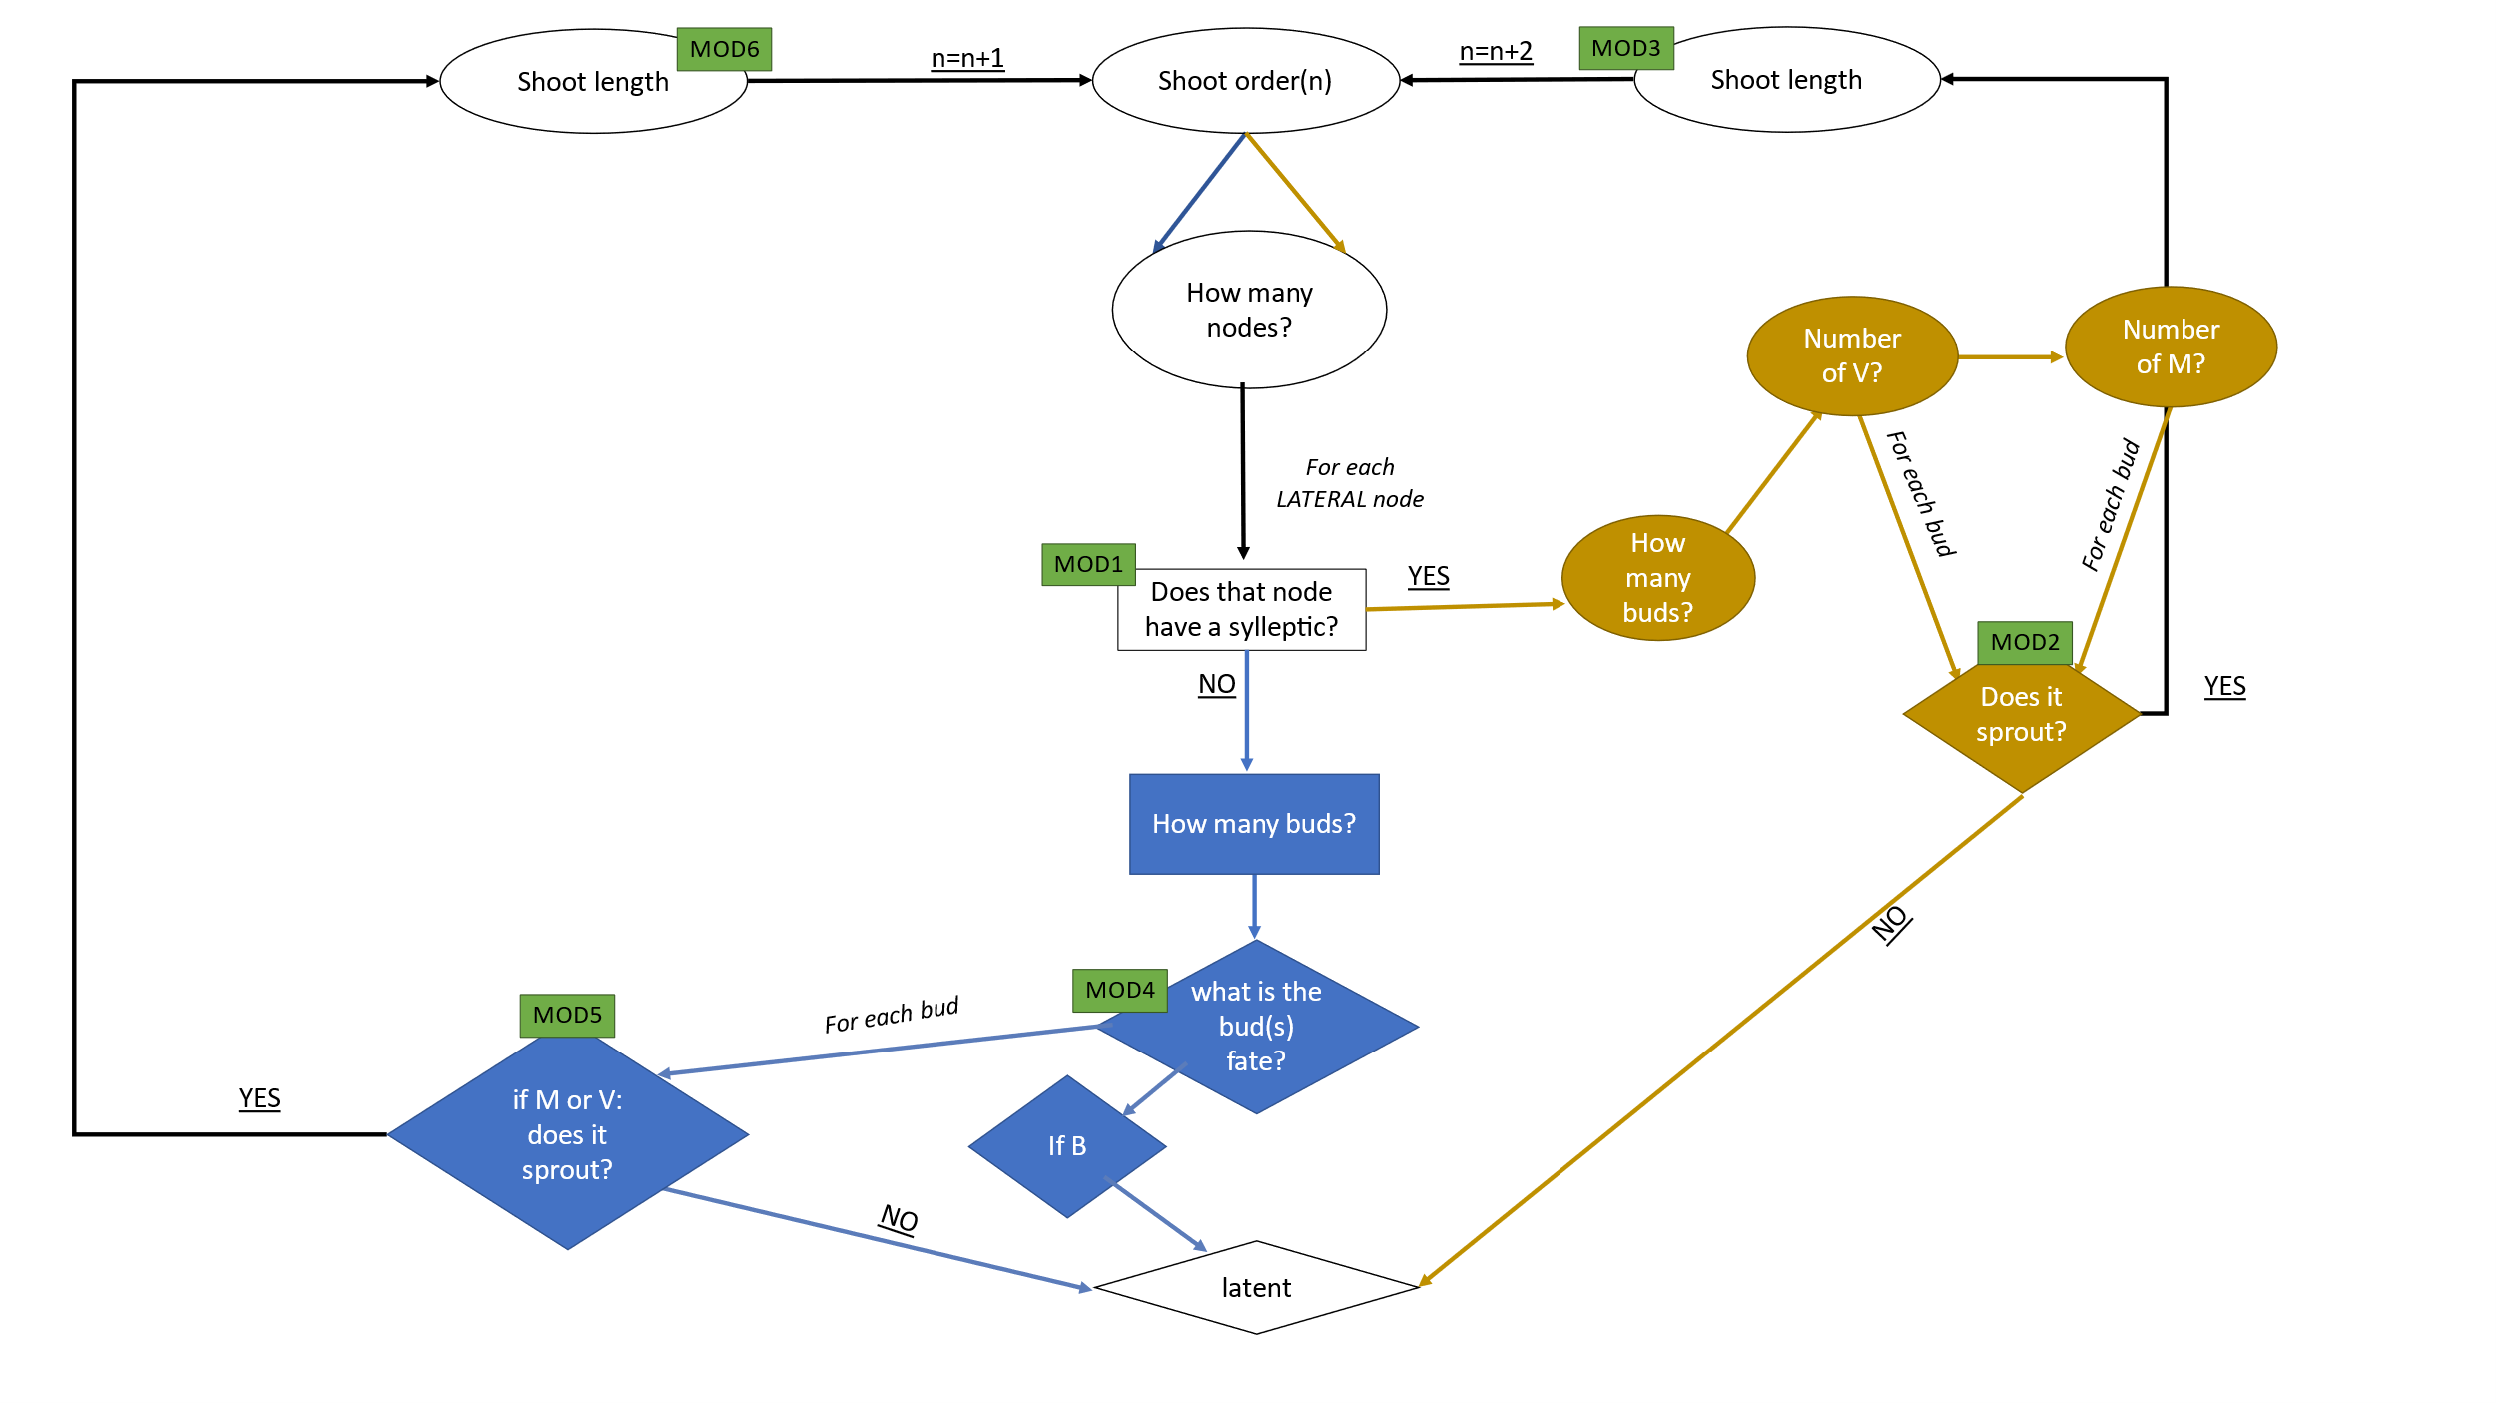



Figure 4:Logical diagram of the architectural model. Each box represents a step that needs to be followed to draw the architecture of hazelnut. Different scales are possible: shoot scale (circled boxes), node scale (squared boxes) and bud scale (rhomboid boxes).

|  |  |  |  |  |  |  |  |
| --- | --- | --- | --- | --- | --- | --- | --- |
| Model ID | Question | SHOOT TYPE | Scale | Tested factors | Model type | Signf. | Figures and table |
| MOD1 | Does that node have a sylleptic? | Proleptic | Rank | Normalized distance | Binomial GLM | *** | Figure 5 |
| MOD2 | Does it sprout? | Sylleptic | Bud | FateV*otherV | Binomial GLM with interaction | *** | Figure 6 |
| FateV*otherM | Ns |
| FateM*otherV | Ns |
| FateM*otherM | * |
| MOD3 | New shoot length | Sylleptic | Shoot | Distribution length of new shoots from sylleptic | | *** | Figure 7 |
| MOD4 | What is the bud(s) fate? | Proleptic | Rank | Rank node | Multinomial | *** | Figure 8 |
| Rank node^0.5 | *** |
| Rank node^2 | *** |
| Rank node^3 | *** |
| Rank node^4 | *** |
| MOD5 | If M or V: does it sprout? | Proleptic | Bud | Siblings | Binomial GLM | *** | Figure 9 |
| Normalized distance | *** |
| MOD6 | New shoot length | Proleptic | Shoot | FateV*parent length | Gaussian GLM | *** | Figure 10 |
| FateV*nomalized distance | *** |
| FateM*parent length | *** |
| FateM*normalized distance | *** |

Table 1: summary tables of all the models. For each one the name, the answered question, the shoot type and the scale are mentioned. Then the factor tested, the significance and the type of model are stated for each model.

Figure 5: **MOD1**. relationship between proportion of sylleptic shoots (computed as number of sylleptic shoots / total number of nodes) with distance from parental median node (0 is the median node). In blue the real data while in red the data predicted by the GLM.

Table 2: GLM output of MOD2. Dependent variable was the proportion of new shoots from sylleptic shoots. Predictors were bud fates ( V or M) interacting with the presence of other M or V buds in the same sylleptic. AIC= 670.44. Significance was found in the intercept (Fate V), in the interaction between fate V and other V buds, and in the interaction between fate M and other M buds.

Figure 6: **MOD2.** Graphical representation of proportion of new shoots from sylleptic shoots according to bud fate ( V or M) and the presence of other M or V buds in the same sylleptic. GLMs output showed significance in the interaction between fate V and other V buds, in the interaction between fate M and other M buds.In the graph, the points represents the real data while lines are the predicted value using glms equations. Polygons represent confidence interval. The factorAIC=670.44.

Figure 7: **MOD3.** Density distribution of length of new shoots, born in sylleptic shoots, whatever the type of bud (M or V). The distribution of length follows a gamma distribution with α=2.38 and β=1.20.

Figure 8: **MOD4.** Proportion of V, B, and M buds according to parent rank node, in proleptic shoots.

Table 3: GLM output of **MOD5**. Dependent variable was the proportion of new shoots from proleptic shoots. Predictors sibling buds (sib: V or M) and normalized distance from the median rank node. AIC= 625.57. Significance was found in all the predictors.

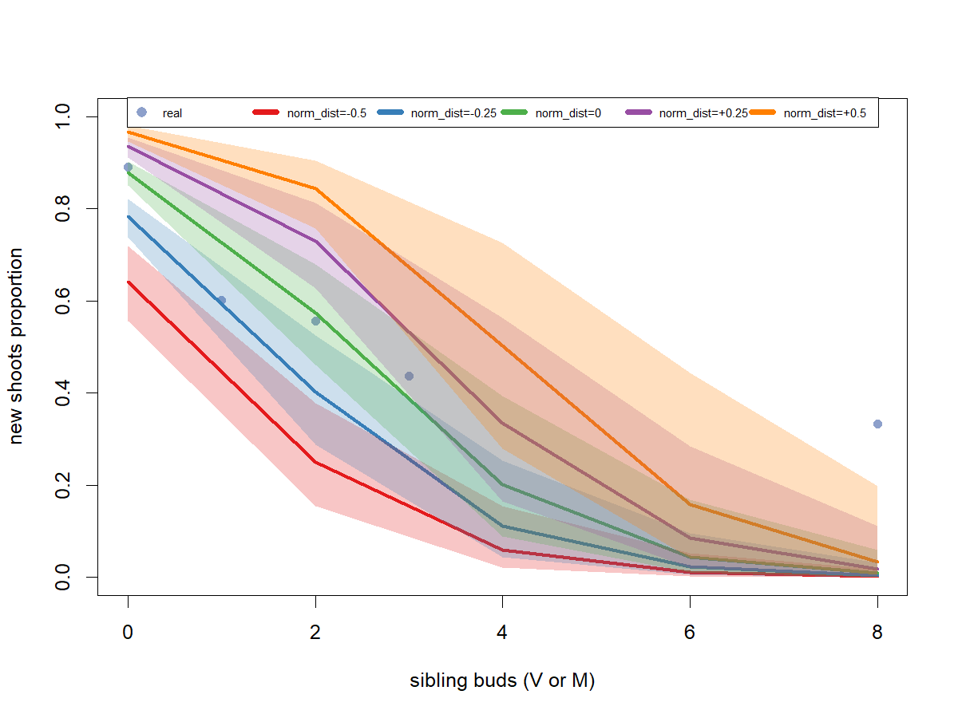

Figure 9: **MOD5.** relationship between proportion of new shoot, presence of other buds in the same node (sibling buds), and normalized distance from median node. The blu dots represent the real proportions. Different colors are the predicted values for different normalized distances. Trasparent polygons are the confidence interval of each predicted value. AIC=625.57.

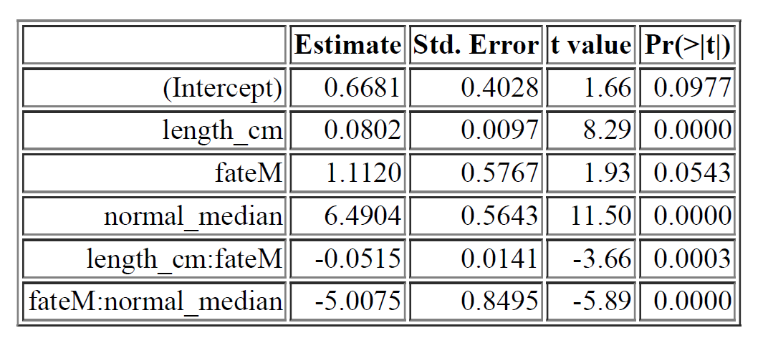

Table 4: GLM output of **MOD6**. Dependent variable was the length of new shoots from proleptic shoots. Predictors are length of parent shoot and normalized distance from the median rank node. The interaction was made with the fare (V or M) of the bud. AIC= 3335. Significance was found in all the predictors besides the intercepts.

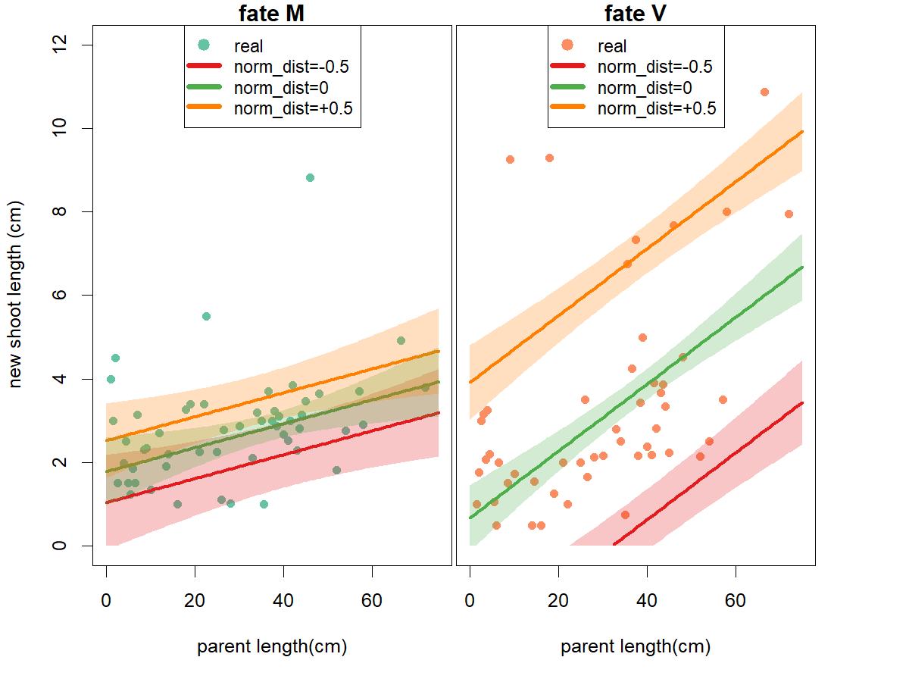

Figure 10: **MOD6.** relationship between length of new shoots, bud fate, parent length and distance from median rank node. The green and orange dots represent the real proportions of new shoots from Mixed and Vegetative buds, respectively. Different colors are the predicted values for different normalized distances. Trasparent polygons are the confidence interval of each predicted value. AIC=3335.